# VCNC COMMITTEE BIOGRAPHY

**Title/Role:** Founder and Legal Representative

**Name:** Gilbert Niyomuhoza



# Introduction (1-3 sentences):

With experience in communication, Sales and Marketing, passion for education and community improvement, Gilbert has consistently engaged in activities that bring people seeking to address the most pressing social issues to promote wellbeing in the community. Professionally, Gilbert has been involved in various professions such as teaching, customer services, sales and marketing. He holds a bachelor’s degree in Communications from Southern New Hampshire University, and is currently pursuing Master’s degree in International Relations and Diplomacy and Mount Kenya University. VCNC speaks Humanity to me, and that’s what moves me. I would like to see every member of society cared for, irrespective of their social, economic, educational or historical background. VCNC gives a platform to contribute to this.

Being on the committee is an assignment to contribute to an honest and transparent leadership and management that overly realize the vision and mission of VCNC. My interest spans from having fun with children, making a positive impact in the community, and enabling an accountable leadership of the organization.

# Experience (2-3 sentences):

* Mention relevant professional experience, education, or achievements that demonstrate your qualifications for the committee.
* Focus on expertise that contributes to the committee's area of work.

# Committee Involvement (2-3 sentences):

* Briefly describe your goals for the committee and how you plan to contribute.
* Mention any specific areas of interest within the committee's work.

**Title/Role:** Strategic Planning and Development Manager

**Name:** Benitha ISABANE

# A professional picture

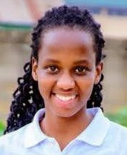

Going with the names: Benitha Isabane, a 3+ years seasoned Logistics and Operations Management professional with a knack for maximizing potential. Currently advancing her skills with an MBA in Project Management, She has honed her expertise in data, people, inventory, delivery and transport management. What ignites her passion? Is the chance to join the VCNC committee, where she can blend her experience with a mission close to her heart: empowering vulnerable children. She thrives on crafting strategic plans and fostering community engagement, and she is ready to dive in by collaborating to make a real impact.

# Experience (2-3 sentences):

Benitha's expertise in data,people and inventory management ensures strategic planning and resource optimization for VCNC. Her proficiency in people and operations management maximizes team potential and project coordination.

# Committee Involvement (2-3 sentences):

Her goal for the committee is to maximize each member's contribution through strategic planning for short and long-term objectives. She will identify opportunities and resources aligned with VCNC's mission, ensuring efficient utilization. Additionally, She will uphold

operational compliance with VCNC protocols and governmental standards for effective execution.

**Title/Role:** Finance Manager **Name:** Jean Marie Ndayambaje **A professional picture**

# Introduction (1-3 sentences):

Jean Marie is a Bachelor holder, with experience working with marginalized people and refugees. He specializes in communication and that makes him a good asset to raise advocacy to most people in need, especially refugees. Prior to joining VCNC, he worked with both international and local institutions whereby he worked at Give Directly, AOG Rwanda, Moretti Foundation, etc. His big win is seeing a marginalized (underprivileged) person enjoy their lives thanks to his support. He assisted various individuals to access different opportunities ranging from tertiary education to jobs from the refugee camps. The skills he holds from different experiences will help me work closely to meet the VCNC vision and mission as he possesses networking, communication, and decision-making skills to help him engage with different stakeholders.

# Experience (2-3 sentences):

Jean Marie has been working with the Moretti Foundation as its country representative in Rwanda and part of his responsibilities included but not limited to overseeing the foundation’s budget and all financial decisions. This aligns with his main goals to follow up the VCNC financial records.

# Committee Involvement (2-3 sentences):

My goal is to ensure that activities of VCNC are running smoothly in a clear and effective way. I also want to bring in new innovative ideas that might contribute to the growth of VCNC as an organization and the development of children.

**Title/Role:** Outreach and Community Engagement Manager

**Name:** Furaha Joyce Croyance

# A professional picture

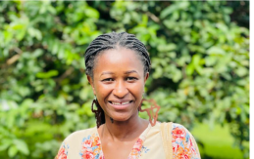

**Introduction (1-3 sentences):**

Furaha is a bachelor holder in Geography hons in Environmental management from University of Rwanda ,she is advancing her skills in MDS (Masters in Development Studies) at Kigali Independent University (ULK) , she worked with peace education activities in the Ideas Box Digital Library where she facilitated youth and children in the Mugombwa Refugee Camp. She also worked as a volunteer librarian for the Transformational Leadership Center (TLC) in one of their Children’s Peace Libraries in Rwanda. With this experience of working with children this will help working strongly with VCNC Vision and mission for caring the life of vulnerable kids and engaging the community.

I’m honored to serve as outreach and community management by contributing effectively and making a positive impact to the community as well as meeting the VCNC vision and mission.

**Title/Role:** Communications Manager

# Name:

**A professional picture Introduction (1-3 sentences):**

* Briefly introduce yourself and your background.
* Highlight what excites you about being on the VCNC committee and how your skills or experience align with the committee's goals.

# Experience (2-3 sentences):

* Mention relevant professional experience, education, or achievements that demonstrate your qualifications for the committee.
* Focus on expertise that contributes to the committee's area of work.

# Committee Involvement (2-3 sentences):

* Briefly describe your goals for the committee and how you plan to contribute.
* Mention any specific areas of interest within the committee's work.

**Title/Role:** General Advisor **Name:** Liome KWIHANGANA **Professional Picture**

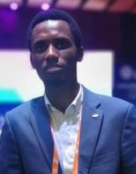

I am an experienced educational advisor, resilient and climate change advocate in line with UN-SDGs with the exceptional expertise to engage vulnerable youth, children and communities. I have contributed to the implementation of UKAIK, DUBAI CARE and The Lego Foundation projects through humanitarian and international development intervention, in technical and networking positions. Moreover, I am qualified in education, a holder of a Diploma in project management and a bachelor of International Business Management, all from recognized institutions.

# Experience:

I have over 5 years of experience working with most disadvantaged communities, youth and children. From the start, the ultimate vision remained the same: create a fair world for everyone by empowering the targets in different areas and get them engaged in their own sustainable development.

# Committee involvement

I am accountable for providing VCNC departments with technical support and advice to ensure the efficiency and effectiveness of the humanitarian service that we provide to our stakeholders/primary actors.

**Title/Role:** General Advisor

**Name:** Gloria Hirwa

# A professional picture

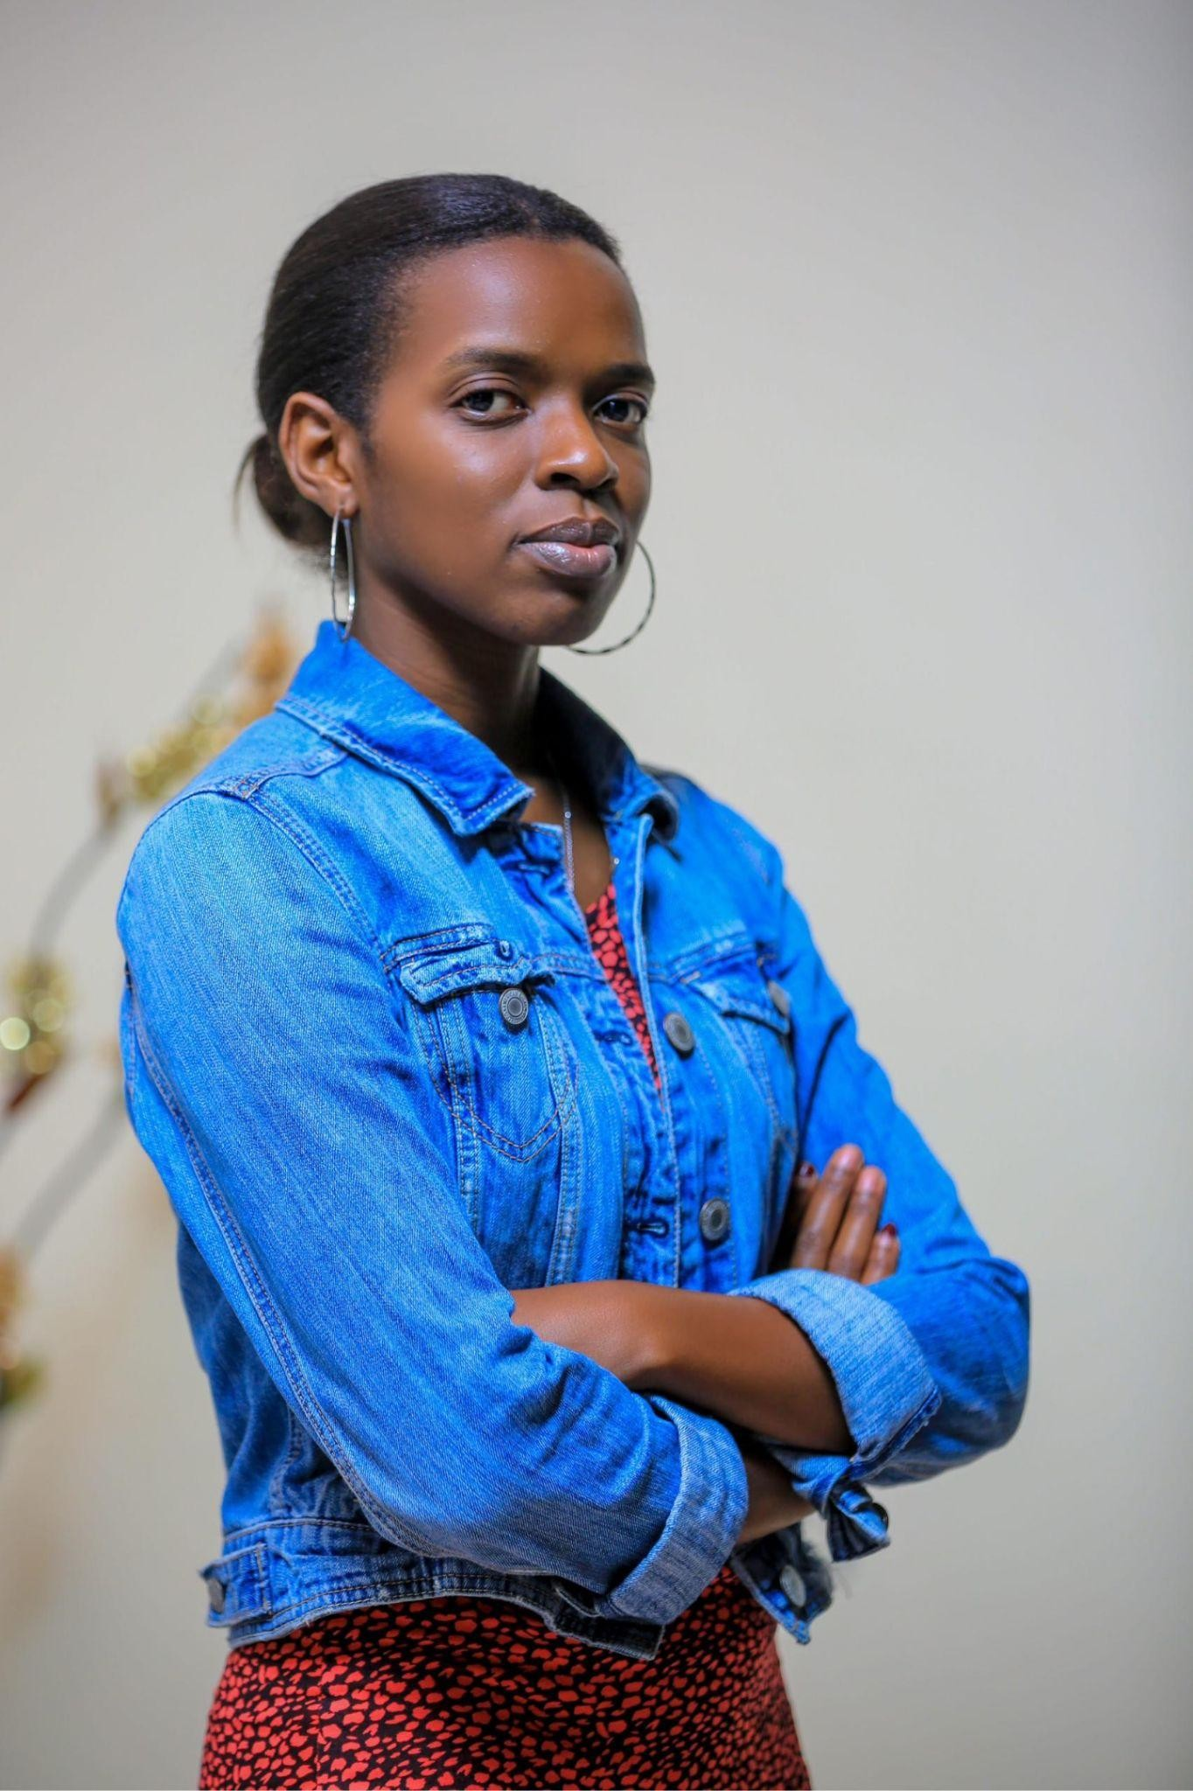

**Introduction (1-3 sentences):**

Dynamic and results-oriented professional with a proven track record in customer relations and data analytics, complemented by a Bachelor of Arts in Health Care Management with a focus on Global Perspectives. I am passionate about being in VCNC because I love helping people, especially children who never chose the circumstances they were born into. It contributes to making the world better. My skills in problem solving and data analysis contribute to the tasks required for this position such as monitoring and evaluation which is necessary in the development of VCNC.

# Experience (2-3 sentences):

I have experience in data manipulation which contributes to the monitoring and evaluation role. I also have problem solving skills which help in the task of bringing up new innovative ideas to the team.

# Committee Involvement (2-3 sentences):

My goal is to ensure that activities of VCNC are running smoothly in a clear and effective way. I also want to bring in new innovative ideas that might contribute to the growth of VCNC as an organization and the development of children.

**Title/Role:** Secretary **Name:** Marie Gisele Iraguha **A professional picture**



# Introduction

A seasoned professional, honed my skills in evaluating and enhancing team performance, providing strategic insights and support to underperforming staff. My proficiency in creating comprehensive reports ensures informed decision-making across various stakeholders. Additionally, I am serving as VCNC secretary, committed to seeing a positive impact in the lives of these children. I am passionate about leveraging my expertise to drive positive change and maximize impact in every endeavor I undertake.

# Experience

With a background in evaluating and enhancing team performance, supported by a strong educational foundation, I bring relevant skills to the committee. My experience in creating comprehensive reports and organizing impactful events aligns well with the committee's objectives. Additionally, serving as VCNC secretary reflects my commitment to making a positive impact in the lives of underprivileged children. My expertise in strategic decision-making, honed through professional experience, complements the committee's focus on driving positive change. I am eager to leverage my qualifications to contribute effectively to making a positive change in children’s lives

# Committee Involvement

Honored to Serve as the Secretary at VCNC, hence contributing to our mission-driven work. Proud to be part of a team making a positive impact in the community